2022

Sharad Pise

Birlasoft Limited.

10/10/2022

GraphQL Documentation



Table of Contents

Introduction to GraphQL with .NET Core Web API Project 2

Integration of GraphQL in ASP.NET Core 4

Creating GraphQL Specific Objects (Type, Query, Schema) 5

AppQuery Explanation 7

Libraries and Schema Registration 8

Sending the First Query 9

Creating Complex Types for GraphQL Queries 9

Adding Enumerations in GraphQL Queries 11

Implementing a Cache in the GraphQL Queries with Data Loader 13

Using Arguments in Queries and Handling Errors 15

Aliases, Fragments, Named Queries, Variables, Directives 17

Input Types and Schema Enhancing for the GraphQL Mutations 20

Create Mutation 20

Update Mutation 22

Delete Mutation 23

Preparing the ASP.NET Core Client Project 25

Creating Model Classes 26

Creating Queries and Mutations to Consume GraphQL API 27

Implementing a Controller 29

Additional Resources 31

Angular application to consume the GraphQL API, by using the Apollo library. 31

GraphQL For .Net 31

# Introduction to GraphQL with .NET Core Web API Project

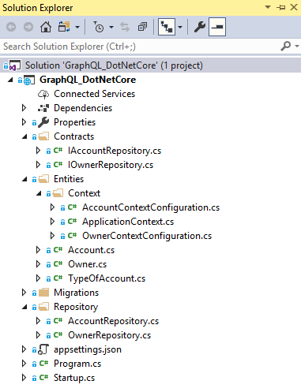

The Contracts folder contains interfaces required for our repository logic:

namespace GraphQLDotNetCore.Contracts

{

public interface IOwnerRepository

{

}

}

namespace GraphQLDotNetCore.Contracts

{

public interface IAccountRepository

{

}

}

In the Entities folder, we keep model classes with a context class and the seed configuration classes:

public class Owner

{

[Key]

public Guid Id { get; set; }

[Required(ErrorMessage = "Name is required")]

public string Name { get; set; }

public string Address { get; set; }

public ICollection<Account> Accounts { get; set; }

}

public class Account

{

[Key]

public Guid Id { get; set; }

[Required(ErrorMessage = "Type is required")]

public TypeOfAccount Type { get; set; }

public string Description { get; set; }

[ForeignKey("OwnerId")]

public Guid OwnerId { get; set; }

public Owner Owner { get; set; }

}

public enum TypeOfAccount

{

Cash,

Savings,

Expense,

Income

}

public class ApplicationContext : DbContext

{

public ApplicationContext(DbContextOptions options)

:base(options)

{

}

protected override void OnModelCreating(ModelBuilder modelBuilder)

{

var ids = new Guid[] { Guid.NewGuid(), Guid.NewGuid() };

modelBuilder.ApplyConfiguration(new OwnerContextConfiguration(ids));

modelBuilder.ApplyConfiguration(new AccountContextConfiguration(ids));

}

public DbSet<Owner> Owners { get; set; }

public DbSet<Account> Accounts { get; set; }

}

And in a Repository folder, we have classes related to the data fetching logic:

public class OwnerRepository : IOwnerRepository

{

private readonly ApplicationContext _context;

public OwnerRepository(ApplicationContext context)

{

_context = context;

}

}

public class AccountRepository : IAccountRepository

{

private readonly ApplicationContext _context;

public AccountRepository(ApplicationContext context)

{

_context = context;

}

}

The context class and repository classes are registered inside the Startup.cs class:

public void ConfigureServices(IServiceCollection services)

{

services.AddDbContext<ApplicationContext>(opt =>

opt.UseSqlServer(Configuration.GetConnectionString("sqlConString")));

services.AddScoped<IOwnerRepository, OwnerRepository>();

services.AddScoped<IAccountRepository, AccountRepository>();

services.AddControllers()

.AddNewtonsoftJson(o => o.SerializerSettings.ReferenceLoopHandling = Newtonsoft.Json.ReferenceLoopHandling.Ignore);

}

So, at this point, all you have to do is to modify the connection string (if you have to) in the appsettings.json file and to navigate to the Package Manager Console, and run the update-database command. Once you do that, we are ready to move on.

As you can see, we are using the Code-First approach in the starter project.

# Integration of GraphQL in ASP.NET Core

Since the GraphQL support is not provided inside the ASP.NET Core applications, we must install a few new libraries. So, the first library we are going to install is GraphQL and we can install it via NuGet package manager:

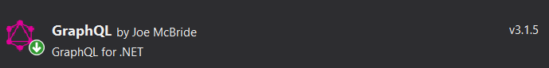

In addition, we can use the Package Manager Console: PM> Install-Package GraphQL -Version 3.1.5

The second library we want to install is GraphQL.Server.Transports.AspNetCore, which will help us to get GraphQL.NET as a dependency:

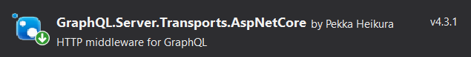

The Package Manager command: PM> Install-Package GraphQL.Server.Transports.AspNetCore -Version 4.3.1

We must support serialization for GraphQL, and for that, we require another package:

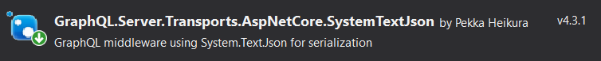

PM> Install-Package GraphQL.Server.Transports.AspNetCore.SystemTextJson -Version 4.3.1

Finally, we are going to install GraphQL.Server.Ui.Playground library, which will help us send the GraphQL queries to the server:

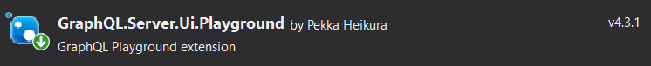

The PM command: PM> Install-Package GraphQL.Server.Ui.Playground -Version 4.3.1

Once we are finished with the installations, we can move on to the integration logic.

## Creating GraphQL Specific Objects (Type, Query, Schema)

Let’s start by creating a new folder named GraphQL and inside a new one with the name GraphQLSchema with a single class AppSchema.cs:

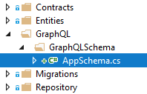

public class AppSchema : Schema

{

public AppSchema(IServiceProvider provider)

:base(provider)

{

}

}

This class must inherit from the Schema class which resides in the GraphQL.Types namespace. Inside the constructor, we inject the IServiceProvider which is going to help us provide our Query, Mutation, or Subscription objects.

What’s important to know is that each of the schema properties (Query, Mutation, or Subscription) implements IObjectGraphType which means that the objects we are going to resolve must implement the same type as well. This also means that our GraphQL API can’t return our models directly as a result but GraphQL types that implement IObjectGraphType instead.

So, let’s leave this class for a moment and create a new folder GraphQLTypes with a single class OwnerType.cs inside the GraphQL folder:

public class OwnerType : ObjectGraphType<Owner>

{

public OwnerType()

{

Field(x => x.Id, type: typeof(IdGraphType)).Description("Id property from the owner object.");

Field(x => x.Name).Description("Name property from the owner object.");

Field(x => x.Address).Description("Address property from the owner object.");

}

}

This is the OwnerType class which we use as a replacement for the Owner model inside a GraphQL API. This class inherits from a generic ObjectGraphType<Owner> class which at some point (in the hierarchy) implements IObjectGraphType interface. With the Field method, we specify the fields which represent our properties from the Owner model class.

To continue, let’s create another folder GraphQLQueries with a class AppQuery, inside the GraphQL folder.

But before we modify this class, let’s modify the IOwnerRepository interface:

public interface IOwnerRepository

{

IEnumerable<Owner> GetAll();

}

And the OwnerRepository class:

public class OwnerRepository : IOwnerRepository

{

private readonly ApplicationContext _context;

public OwnerRepository(ApplicationContext context)

{

_context = context;

}

public IEnumerable<Owner> GetAll() => _context.Owners.ToList();

}

Now, we can modify the AppQuery class to reflect those changes:

public class AppQuery : ObjectGraphType

{

public AppQuery(IOwnerRepository repository)

{

Field<ListGraphType<OwnerType>>(

"owners",

resolve: context => repository.GetAll()

);

}

}

### AppQuery Explanation

As we can see, this class inherits from the ObjectGraphType as well, just the non-generic one. Moreover, we inject our repository object inside a constructor and create a field to return the result for the specific query.

In this class, we use the generic version of the Field method which accepts some „strange“ type as a generic parameter. Well, this is the GraphQL.NET representation for the normal .NET types. So, ListGraphType is the representation of the List type, and of course, we have IntGraphType or StringGraphType, etc… For the complete list visit SchemaTypes in GraphQL .NET.

The „owners“parameter is a field name (query from the client must match this name) and the second parameter is the result itself.

Having done our preparations, we can now modify our AppSchema class:

public class AppSchema : Schema

{

public AppSchema(IServiceProvider provider)

:base(provider)

{

Query = provider.GetRequiredService<AppQuery>();

}

}

Well done. Let’s proceed to schema registration.

### Libraries and Schema Registration

In a Startup class, we need to register our installed libraries and the created schema class as well. So, let’s do that by modifying the ConfigureServices and Configure methods:

public void ConfigureServices(IServiceCollection services)

{

services.AddDbContext<ApplicationContext>(opt =>

opt.UseSqlServer(Configuration.GetConnectionString("sqlConString")));

services.AddScoped<IOwnerRepository, OwnerRepository>();

services.AddScoped<IAccountRepository, AccountRepository>();

services.AddScoped<AppSchema>();

services.AddGraphQL()

.AddSystemTextJson()

.AddGraphTypes(typeof(AppSchema), ServiceLifetime.Scoped);

services.AddControllers()

.AddNewtonsoftJson(o => o.SerializerSettings.ReferenceLoopHandling = Newtonsoft.Json.ReferenceLoopHandling.Ignore);

services.Configure<KestrelServerOptions>(options =>

{

options.AllowSynchronousIO = true;

});

}

// This method gets called by the runtime. Use this method to configure the HTTP request pipeline.

public void Configure(IApplicationBuilder app, IWebHostEnvironment env)

{

if (env.IsDevelopment())

{

app.UseDeveloperExceptionPage();

}

app.UseHttpsRedirection();

app.UseRouting();

app.UseAuthorization();

app.UseGraphQL<AppSchema>();

app.UseGraphQLPlayground(options: new GraphQLPlaygroundOptions());

app.UseEndpoints(endpoints =>

{

endpoints.MapControllers();

});

}

In the ConfigureServices method, we register the DependencyResolver (for our queries) and the schema class as well. Furthermore, we register GraphQL with the AddGraphQL method and register all the GraphQL types (Query and Type classes) with the AddGraphTypes method. Without this method, we would have to register all the types and queries manually in our API.

Finally, in the Configure method, we are adding our schema to the request’s pipeline as well as the Playground UI tool which we are just about to use

### Sending the First Query

To test our GraphQL API, we are going to use the GraphQL.UI.Playground tool. So, let’s first start our server application and then navigate to the https://localhost:5001/ui/playground address:



Excellent, we see that everything is working just as it supposed to. As soon as we send our query, with the name „owners“ (which must match the query name we created in the AppQuery file), we get the required result.

# Creating Complex Types for GraphQL Queries

If we take a look at our „owners“query, we are going to see it returns the ListGraphType<OwnerType> result. Furthermore, if we inspect the OwnerType class, we are going to see it contains the Id, Name and Address fields. But a single Owner can have multiple accounts related to it, this can be confirmed by inspecting the Owner model class in the Entities folder. So, this is exactly what we want to add to the OwnerType class as well.

But, before we start with adding additional Accounts field into the OwnerType class, we need to create the AccountType class first. So let’s do that inside the GraphQLTypes folder:

public class AccountType : ObjectGraphType<Account>

{

public AccountType()

{

Field(x => x.Id, type: typeof(IdGraphType)).Description("Id property from the account object.");

Field(x => x.Description).Description("Description property from the account object.");

Field(x => x.OwnerId, type: typeof(IdGraphType)).Description("OwnerId property from the account object.");

}

}

Yes, we are missing the Type property from the Account class, but we will get to that.

Now, that we have AccountType, we can add a list of accounts to our „owners“ query result. So, let’s start by modifying the IAccountRepository interface first and then the AccountRepository class:

public interface IAccountRepository

{

IEnumerable<Account> GetAllAccountsPerOwner(Guid ownerId);

}

public class AccountRepository : IAccountRepository

{

private readonly ApplicationContext _context;

public AccountRepository(ApplicationContext context)

{

_context = context;

}

public IEnumerable<Account> GetAllAccountsPerOwner(Guid ownerId) => _context.Accounts

.Where(a => a.OwnerId.Equals(ownerId))

.ToList();

}

Now, we can modify the OwnerType class:

public class OwnerType : ObjectGraphType<Owner>

{

public OwnerType(IAccountRepository repository)

{

Field(x => x.Id, type: typeof(IdGraphType)).Description("Id property from the owner object.");

Field(x => x.Name).Description("Name property from the owner object.");

Field(x => x.Address).Description("Address property from the owner object.");

Field<ListGraphType<AccountType>>(

"accounts",

resolve: context => repository.GetAllAccountsPerOwner(context.Source.Id)

);

}

}

So, there is nothing in this code, that we haven’t seen so far. In the same way that we have created a field in the AppQuery class, we create a field in the OwnerType class. One interesting thing is that the GetAllAccountsPerOwner method requires an id parameter but we provide context.Source.Id.

That’s because the context contains the Source property which is of the Owner type in this specific case:

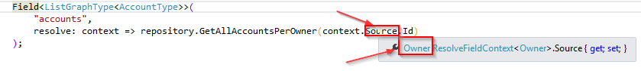

Finally, we can modify the „owners“ query in the UI.Playground:



## Adding Enumerations in GraphQL Queries

In the AccountType class, we are missing the Type field. We left it out deliberately, and now it’s the right time to add it. To add enumeration to the AccountType class, we need to invest just a little bit more effort than with the regular scalar types in GraphQL.

The first thing we are going to do is to create a new class AccountTypeEnumType in the GraphQLTypes folder:

public class AccountTypeEnumType : EnumerationGraphType<TypeOfAccount>

{

public AccountTypeEnumType()

{

Name = "Type";

Description = "Enumeration for the account type object.";

}

}

We can see that the AccountTypeEnumType class must inherit from the generic EnumerationGraphType which for the generic parameter has the enumeration that we have created in our starter project. One important thing to mention is that the value for the Name property must mache the name of the same enumeration property inside the Account class:

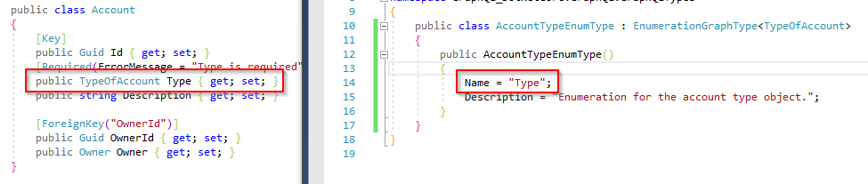

After this modification, let’s add this enumeration type in the AccountType class:

public class AccountType : ObjectGraphType<Account>

{

public AccountType()

{

Field(x => x.Id, type: typeof(IdGraphType)).Description("Id property from the account object.");

Field(x => x.Description).Description("Description property from the account object.");

Field(x => x.OwnerId, type: typeof(IdGraphType)).Description("OwnerId property from the account object.");

Field<AccountTypeEnumType>("Type", "Enumeration for the account type object.");

}

}

Finally, we can add the enumeration type to our client query:



## Implementing a Cache in the GraphQL Queries with Data Loader

Our query is returning the expected result, we’ve seen that, but it is not that optimized enough yet.

So, what is the problem?

Well, the problem is that our query is working in such a way that it extracts id’s from all the owners and then for every single id sends the additional SQL query to the database to fetch related accounts. We can see that from the logs:

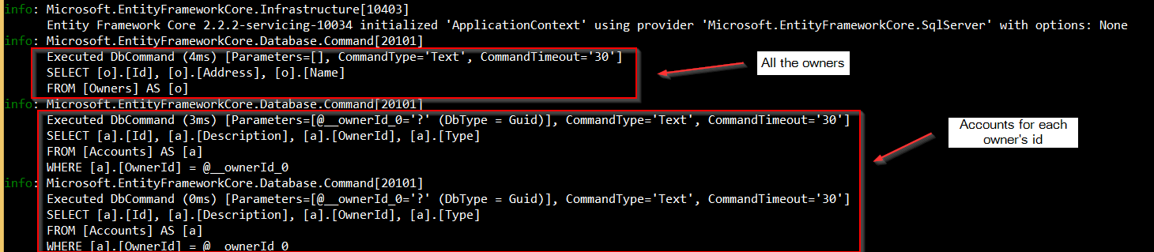

Of course, this is not a problem when we have only two owner entities, but what if we have a thousand?

We can optimize this query by using DataLoader which is provided by GraphQL, with a couple of modifications.

Let’s start by modifying the IAccountRepository file:

public interface IAccountRepository

{

IEnumerable<Account> GetAllAccountsPerOwner(Guid ownerId);

Task<ILookup<Guid, Account>> GetAccountsByOwnerIds(IEnumerable<Guid> ownerIds);

}

We need to have a method that returns Task<ILookup<TKey, T> because DataLoader requires a method with that return type in its signature.

Then, we need to implement this additional method inside the AccountRepository class:

public class AccountRepository : IAccountRepository

{

private readonly ApplicationContext _context;

public AccountRepository(ApplicationContext context)

{

_context = context;

}

public IEnumerable<Account> GetAllAccountsPerOwner(Guid ownerId) => _context.Accounts

.Where(a => a.OwnerId.Equals(ownerId))

.ToList();

public async Task<ILookup<Guid, Account>> GetAccountsByOwnerIds(IEnumerable<Guid> ownerIds)

{

var accounts = await _context.Accounts.Where(a => ownerIds.Contains(a.OwnerId)).ToListAsync();

return accounts.ToLookup(x => x.OwnerId);

}

}

To continue, we are going to modify the OwnerType class:

public class OwnerType : ObjectGraphType<Owner>

{

public OwnerType(IAccountRepository repository, IDataLoaderContextAccessor dataLoader)

{

Field(x => x.Id, type: typeof(IdGraphType)).Description("Id property from the owner object.");

Field(x => x.Name, type: typeof(IdGraphType)).Description("Name property from the owner object.");

Field(x => x.Address, type: typeof(IdGraphType)).Description("Address property from the owner object.");

Field<ListGraphType<AccountType>>(

"accounts",

resolve: context =>

{

var loader = dataLoader.Context.GetOrAddCollectionBatchLoader<Guid, Account>("GetAccountsByOwnerIds", repository.GetAccountsByOwnerIds);

return loader.LoadAsync(context.Source.Id);

});

}

}

Great job.

As you can see, we inject the IDataLoaderContextAccessor in the constructor and use it with the Context.GetOrAddCollectionBatchLoader method with the name of the loader key as a first parameter and our created method as the second parameter.

The final thing to do is to register DataLoader in the Startup class, by attaching it to the AddGraphQL method:

services.AddGraphQL(o => { o.ExposeExceptions = false; })

.AddGraphTypes(ServiceLifetime.Scoped)

.AddDataLoader();

Now, as soon as we send the same query again, we can inspect our logs:

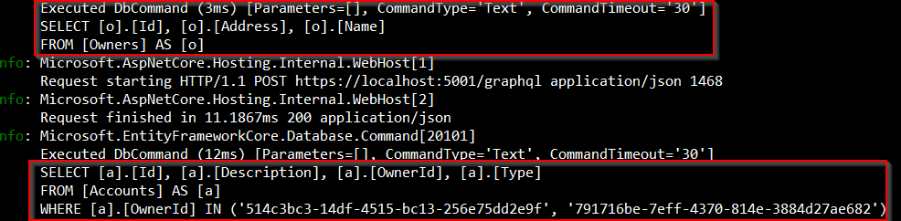

As we can see, we have only one query for all the accounts per each owner.

## Using Arguments in Queries and Handling Errors

Until now, we’ve been returning all the owners with their accounts in a single query. But we want to return a single owner by provided id parameter as well. So to do that, we need to include arguments in our queries.

Let’s do that by modifying the IOwnerRepository interface first:

public interface IOwnerRepository

{

IEnumerable<Owner> GetAll();

Owner GetById(Guid id);

}

Next, we are going to implement the GetById method:

public class OwnerRepository : IOwnerRepository

{

private readonly ApplicationContext _context;

public OwnerRepository(ApplicationContext context)

{

_context = context;

}

public IEnumerable<Owner> GetAll() => _context.Owners.ToList();

public Owner GetById(Guid id) => _context.Owners.SingleOrDefault(o => o.Id.Equals(id));

}

Finally, we can modify the AppQuery class:

public class AppQuery : ObjectGraphType

{

public AppQuery(IOwnerRepository repository)

{

Field<ListGraphType<OwnerType>>(

"owners",

resolve: context => repository.GetAll()

);

Field<OwnerType>(

"owner",

arguments: new QueryArguments(new QueryArgument<NonNullGraphType<IdGraphType>> { Name = "ownerId" }),

resolve: context =>

{

var id = context.GetArgument<Guid>("ownerId");

return repository.GetById(id);

}

);

}

}

So, we create a new field with the OwnerType return value. The name is „owner“ and we use the arguments part to create an argument for this query. Our argument can’t be null (NonNullGraphType) and it must be of the IdGraphType type with the „ownerId“ name. The resolve part is pretty self-explanatory.

But what if the id parameter is not of the Guid type, then, we would like to return a message to the client. So let’s add a slight modification in the resolve part:

Field<OwnerType>(

"owner",

arguments: new QueryArguments(new QueryArgument<NonNullGraphType<IdGraphType>> { Name = "ownerId" }),

resolve: context =>

{

Guid id;

if (!Guid.TryParse(context.GetArgument<string>("ownerId"), out id))

{

context.Errors.Add(new ExecutionError("Wrong value for guid"));

return null;

}

return repository.GetById(id);

}

);

After these changes, we can use our UI tool to send a new query:



## Aliases, Fragments, Named Queries, Variables, Directives

We can modify our queries, on the client side, by introducing the aliases. They are very useful when we want to change the name of our result, or any field in the result. Furthermore, if we have two same queries but with a different argument, we can use aliases to differentiate those queries.

To use them, all we have to do is to type the required word in front of the query or field:



As we can see from a previous example, we have two queries with the same fields.

Now, let’s imagine if we need 10 of them with the same fields just different arguments, that would be a bit hard to read, wouldn’t it? Well, we can solve this by using fragments. Fragments allow us to separate common fields, for different queries, into a separate section and then just reuse that section in all the queries:



To create a named query, we have to use a „query“ keyword in front of the entire query with the query name as well. Then we can pass arguments for the query if we have some. The important thing with the named queries is if a query has an argument we need to use the QUERY VARIABLES window to assign a value for that argument:



Finally, we can add or remove some fields conditionally from our result by using directives in our queries. There are two directives we can use, include and skip:



# Input Types and Schema Enhancing for the GraphQL Mutations

Let’s start with creating a new class OwnerInputType inside the Types folder:

public class OwnerInputType : InputObjectGraphType

{

public OwnerInputType()

{

Name = "ownerInput";

Field<NonNullGraphType<StringGraphType>>("name");

Field<NonNullGraphType<StringGraphType>>("address");

}

}

This is the type that we are going to send from a client as an argument for our mutations. As we can see, this class derives from the InputObjectGraphType class and not from the ObjectGraphType as before.

In the constructor, we just populate the Name property and create two fields. We can see that we don’t have the Id and Accounts properties because we don’t need them for the mutations.

If we can recall the starting article of this series, there we can see that for the queries we had to create the AppQuery class. Well, it is the same for mutations, just we are not going to create the AppQuery class but the AppMutation class inside the GraphQLQueries folder:

public class AppMutation : ObjectGraphType

{

public AppMutation()

{

}

}

Finally, we need to enhance our Schema class, with the Mutation property:

public class AppSchema : Schema

{

public AppSchema(IServiceProvider provider)

:base(provider)

{

Query = provider.GetRequiredService<AppQuery>();

Mutation = provider.GetRequiredService<AppMutation>();

}

}

Excellent. We are ready to create some mutations in our project.

## Create Mutation

Let’s start with the IOwnerRepository interface modification:

public interface IOwnerRepository

{

IEnumerable<Owner> GetAll();

Owner GetById(Guid id);

Owner CreateOwner(Owner owner);

}

We see that the CreateOwner method returns a newly created owner object, which is quite common in GraphQL.

Now, we can add the CreateOwner method inside the OwnerRepository class:

public Owner CreateOwner(Owner owner)

{

owner.Id = Guid.NewGuid();

_context.Add(owner);

_context.SaveChanges();

return owner;

}

Finally, we can modify the AppMutation class:

public class AppMutation : ObjectGraphType

{

public AppMutation(IOwnerRepository repository)

{

Field<OwnerType>(

"createOwner",

arguments: new QueryArguments(new QueryArgument<NonNullGraphType<OwnerInputType>> { Name = "owner" }),

resolve: context =>

{

var owner = context.GetArgument<Owner>("owner");

return repository.CreateOwner(owner);

}

);

}

}

So, we create a field to return the OwnerType object, with the „createOwner“ name, a single argument of the OwnerInputType type and with the resolve action which is going to execute the CreateOwner method from our repository.

And that is it.

Let’s start our project, open Playground and send a request:

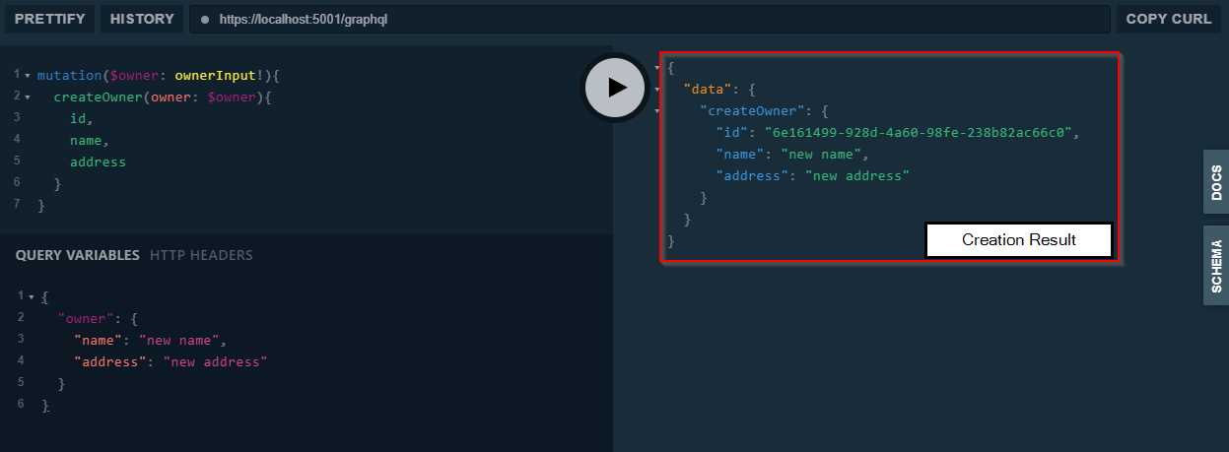

So, instead of the query keyword, we use the mutation keyword for mutations. And this is the only new difference. We have an argument, a call to the createOwner mutation and the fields that we require as a part of the result. On the Playground’s right side, we can see that the creation has been successful and we have a new Owner object returned.

Awesome, now we can continue on.

## Update Mutation

As we did in a previous section of this article, we are going to start with IOwnerRepository modification:

public interface IOwnerRepository

{

IEnumerable<Owner> GetAll();

Owner GetById(Guid id);

Owner CreateOwner(Owner owner);

Owner UpdateOwner(Owner dbOwner, Owner owner);

}

Let’s move on to the OwnerRepository file:

public Owner UpdateOwner(Owner dbOwner, Owner owner)

{

dbOwner.Name = owner.Name;

dbOwner.Address = owner.Address;

_context.SaveChanges();

return dbOwner;

}

Lastly, we have to add an additional field in a constructor of the AppMutation class:

Field<OwnerType>(

"updateOwner",

arguments: new QueryArguments(

new QueryArgument<NonNullGraphType<OwnerInputType>> { Name = "owner" },

new QueryArgument<NonNullGraphType<IdGraphType>> { Name = "ownerId" }),

resolve: context =>

{

var owner = context.GetArgument<Owner>("owner");

var ownerId = context.GetArgument<Guid>("ownerId");

var dbOwner = repository.GetById(ownerId);

if (dbOwner == null)

{

context.Errors.Add(new ExecutionError("Couldn't find owner in db."));

return null;

}

return repository.UpdateOwner(dbOwner, owner);

}

);

Excellent. It is time to test this:

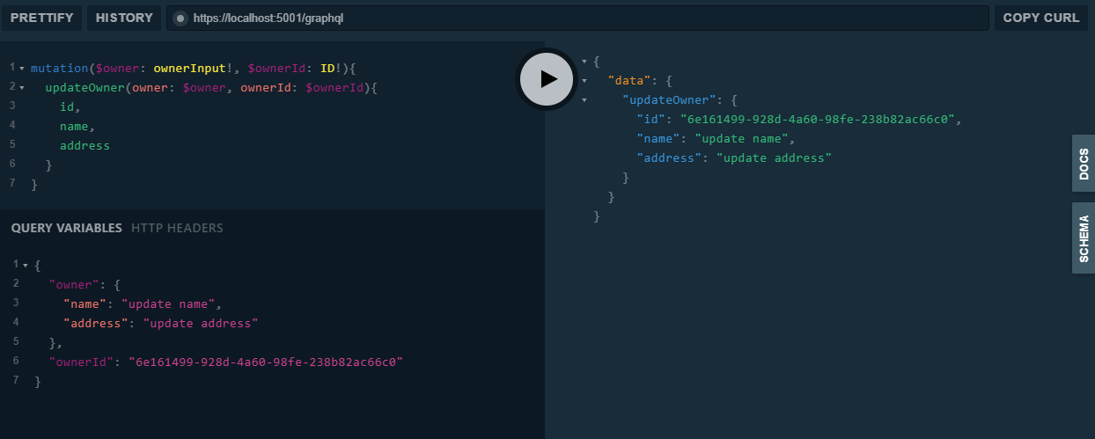

Everything is working as it supposed to.

Let’s move on.

## Delete Mutation

Following the same pattern, let’s modify the interface first:

public interface IOwnerRepository

{

IEnumerable<Owner> GetAll();

Owner GetById(Guid id);

Owner CreateOwner(Owner owner);

Owner UpdateOwner(Owner dbOwner, Owner owner);

void DeleteOwner(Owner owner);

}

Then, let’s continue with the OwnerRepository modification:

public void DeleteOwner(Owner owner)

{

_context.Remove(owner);

_context.SaveChanges();

}

The last thing we need to do is to modify AppMutation file:

Field<StringGraphType>(

"deleteOwner",

arguments: new QueryArguments(new QueryArgument<NonNullGraphType<IdGraphType>> { Name = "ownerId" }),

resolve: context =>

{

var ownerId = context.GetArgument<Guid>("ownerId");

var owner = repository.GetById(ownerId);

if (owner == null)

{

context.Errors.Add(new ExecutionError("Couldn't find owner in db."));

return null;

}

repository.DeleteOwner(owner);

return $"The owner with the id: {ownerId} has been successfully deleted from db.";

}

);

And let’s test this as well:

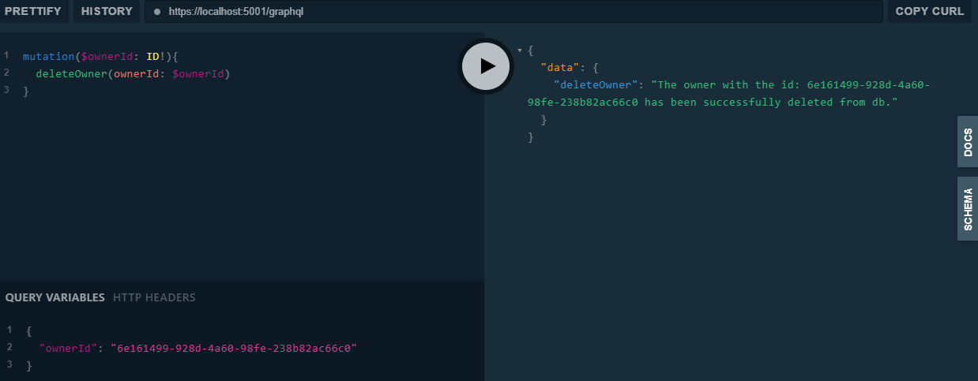  
You can send a query to fetch all the owners and see for your self that this owner entity is not in the database anymore.

# Preparing the ASP.NET Core Client Project

Let’s start, by creating a new ASP.NET Core Web API project. As soon as the project is created, we are going to modify the launchsettings.json file, by setting the launchBrowser property to false and applicationUrl property to https://localhost:5003;http://localhost:5004.

To learn more about ASP.NET Core project configuration, you can read the ASP.NET Core Project Configuration article.

To continue on, let’s modify the appsettings.json file, by adding an address towards the GraphQL application:

{

"Logging": {

"LogLevel": {

"Default": "Information",

"Microsoft": "Warning",

"Microsoft.Hosting.Lifetime": "Information"

}

},

"GraphQLURI": "https://localhost:5001/graphql",

"AllowedHosts": "*"

}

Excellent. Now, we can install the required library:



Or by using the Package Manager Console: PM> Install-Package GraphQL.Client -Version 3.2.0

Additionally, we require one more library for the GraphQL serialization:



PM> Install-Package GraphQL.Client.Serializer.Newtonsoft -Version 3.2.0

After the installation, we are going to register it in the Startup class:

public void ConfigureServices(IServiceCollection services)

{

services.AddScoped<IGraphQLClient>(s => new GraphQLHttpClient(Configuration["GraphQLURI"], new NewtonsoftJsonSerializer()));

services.AddControllers();

}

The next step is creating the OwnerConsumer class, which will store all the queries and mutations:

public class OwnerConsumer

{

private readonly IGraphQLClient _client;

public OwnerConsumer(IGraphQLClient client)

{

_client = client;

}

}

Now let’s register this class:

public void ConfigureServices(IServiceCollection services)

{

services.AddScoped<IGraphQLClient>(s => new GraphQLHttpClient(Configuration["GraphQLURI"], new NewtonsoftJsonSerializer()));

services.AddScoped<OwnerConsumer>();

services.AddControllers();

}

That is it regarding configuration.

## Creating Model Classes

In the first article of this tutorial, you can see that we have the model classes in the starting project. Those classes are also required for the client application, so let’s create them:

public enum TypeOfAccount

{

Cash,

Savings,

Expense,

Income

}

public class Account

{

public Guid Id { get; set; }

public TypeOfAccount Type { get; set; }

public string Description { get; set; }

}

public class Owner

{

public Guid Id { get; set; }

public string Name { get; set; }

public string Address { get; set; }

public ICollection<Account> Accounts { get; set; }

}

We are not done yet. In the third part of this tutorial, GraphQL Mutations, we have created the Input type class for the mutation actions. This class is required as well, so let’s create it:

public class OwnerInput

{

public string Name { get; set; }

public string Address { get; set; }

}

Awesome.

Now we have everything prepared and are ready to start creating queries and mutations.

## Creating Queries and Mutations to Consume GraphQL API

Let’s open the OwnerConsumer class and add the GetAllOwners method:

public async Task<List<Owner>> GetAllOwners()

{

var query = new GraphQLRequest

{

Query = @"

query ownersQuery{

owners {

id

name

address

accounts {

id

type

description

}

}

}"

};

var response = await _client.SendQueryAsync<ResponseOwnerCollectionType>(query);

return response.Data.Owners;

}

As you can see, we are creating a new GraphQLRequest object which contains a Query property for the query we want to send to the GraphQL API. This query is the same as the one we used with the UI.Playground tool in previous articles.

To execute the query, we call the SenQueryAsync method that accepts a response type (as a generic parameter) and the query. Finally, we return the list of owners from this response.

We don’t have the ResponseOwnerCollectionType class, so let’s create a new ResponseTypes folder and inside two new classes:

public class ResponseOwnerCollectionType

{

public List<Owner> Owners { get; set; }

}

public class ResponseOwnerType

{

public Owner Owner { get; set; }

}

Here are all the other queries and mutations from the same class:

**Get Query:**

public async Task<Owner> GetOwner(Guid id)

{

var query = new GraphQLRequest

{

Query = @"

query ownerQuery($ownerID: ID!) {

owner(ownerId: $ownerID) {

id

name

address

accounts {

id

type

description

}

}

}",

Variables = new { ownerID = id }

};

var response = await _client.SendQueryAsync<ResponseOwnerType>(query);

return response.Data.Owner;

}

**Create Mutation:**

public async Task<Owner> CreateOwner(OwnerInput ownerToCreate)

{

var query = new GraphQLRequest

{

Query = @"

mutation($owner: ownerInput!){

createOwner(owner: $owner){

id,

name,

address

}

}",

Variables = new {owner = ownerToCreate}

};

var response = await _client.SendMutationAsync<ResponseOwnerType>(query);

return response.Data.Owner;

}

**Update Mutation:**

public async Task<Owner> UpdateOwner(Guid id, OwnerInput ownerToUpdate)

{

var query = new GraphQLRequest

{

Query = @"

mutation($owner: ownerInput!, $ownerId: ID!){

updateOwner(owner: $owner, ownerId: $ownerId){

id,

name,

address

}

}",

Variables = new { owner = ownerToUpdate, ownerId = id }

};

var response = await _client.PostAsync(query);

return response.GetDataFieldAs<Owner>("updateOwner");

}

**Delete Mutation:**

public async Task<string> DeleteOwner(Guid id)

{

var query = new GraphQLRequest

{

Query = @"

mutation($ownerId: ID!){

deleteOwner(ownerId: $ownerId)

}",

Variables = new { ownerId = id }

};

var response = await _client.SendMutationAsync<ResponseOwnerType>(query);

return response.Data.Owner;

}

## Implementing a Controller

We are going to use the default ValuesController for the testing purpose:

[Route("api/[controller]")]

[ApiController]

public class ValuesController : ControllerBase

{

private readonly OwnerConsumer _consumer;

public ValuesController(OwnerConsumer consumer)

{

_consumer = consumer;

}

[HttpGet]

public async Task<IActionResult> Get()

{

var owners = await _consumer.GetAllOwners();

return Ok(owners);

}

… other actions

}

Now we can test this via Postman:

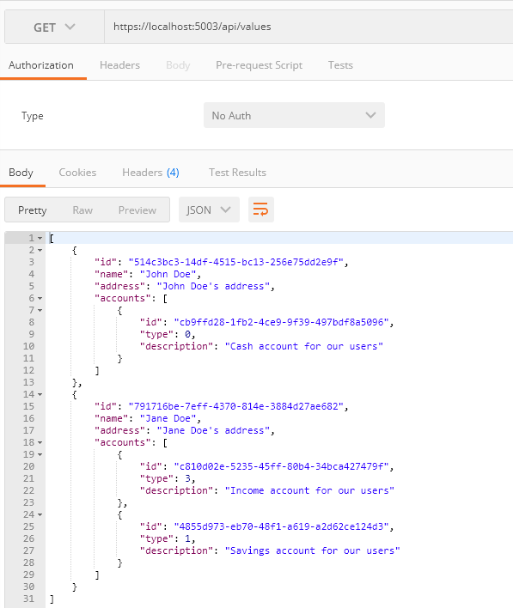

Excellent, it works like a charm. Of course, you can test all the other queries and mutations by using Postman as well.

# Additional Resources

## Angular application to consume the GraphQL API, by using the Apollo library.

<https://code-maze.com/consuming-graphql-api-angular/>

## GraphQL For .Net

You can get more information about GraphQL with .Net on below URL

<https://graphql-dotnet.github.io/docs/getting-started/introduction>